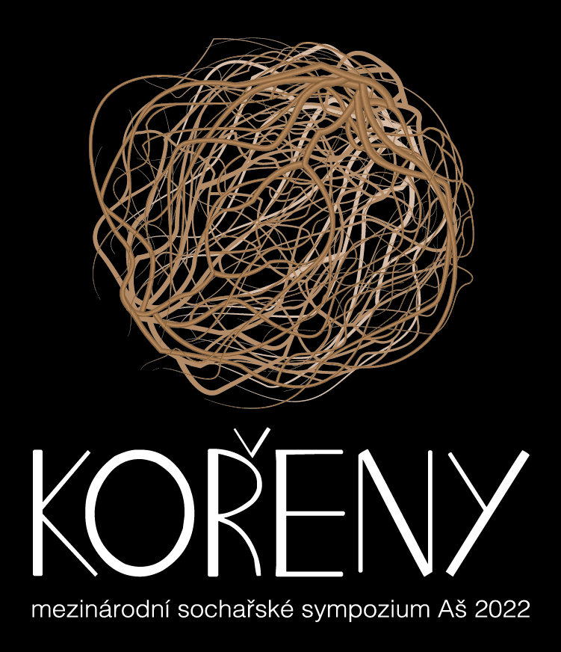

The Roots – International Sculpture Symposium Aš 2022

At opportunity of the celebration of 150 years of Aš to promotion to the city, we announce a sculpture symposium in stone and metal.

Mountain tops are often border between individual nations and states. However, they have been moved more than once in the history of Europe. The nations blended with their neighbors and cooperated together. Common bonds built up generations. All of these has been broken. But, art has no border. The roots left here by past generations, are an inspiration to us.

We want to build the place for good life.

We want to see artists working in our city and exulting of works of Europeans.

The city of Aš supports the relationship and respect for traditional and modern sculptural materials and wants to provide sculptors and visitors conditions for mutual enrichment.

Visitors can watch the art work since first stone break and weld metal. So, they will be part of born of statues and so they will have an opportunity to identify with emerging work. Except interesting and also not knowing moments, this experience brings also new view on fine art and cultivates feeling of viewer. Such enjoyment moves sense not only of young people to new approach to culture and at the same time helps to protect all of art works in public place.

Place: Sady Míru – park near the city centre

Date of announce: December 1, 2021

Application deadline: March 31, 2022

Autors of selected proposal will be informed: April 5, 2022

Date of the symposium: since September 3, 2022, arrival untill 3 p.m. (can be agreed) untill September 17, 2022

Opening on work place: September 17, 2022 at 11 a.m.

Ceremonial unveiling of mounted statues in public place: December 28, 2022 – public holiday – Establish of Czechoslovakia

Choos of sculptores:
The jury contains of representatives of the city, galery, city architect, organizators.

Conditions:
Art symposium is organizated for 8 authors. The jury reserves the possibility to choos less.

Organizator:

- Provides accommodations, diet, drink – free of charge – and costs for transport (5CZK/km) max. 5.000 CZK (can be agreed). Can be paid in Euros according actually course.
- There will be available sandstone from Hořice, ragged form 1m3, steel according sculptore´s claim.

- Electricity connection 220V.

- Protection of work place against the weather – tent (we work in any weather)

- Ensures promotion in media (print, TV, radio, internet).

- Each sculptor will get honorarium 30.000 CZK after his finish of the statue during the symposium. Can be paid in Euros according actually course.

- During the symposium will takes place public voting. The evaluated statue will recieve an People´s price.

- Placement of the statue on a concrete pedestal in public place in Aš.

Sculptor:

- Must be a citizen of European Union.

- Must have health and accident insurance.

- Is responsible for follow the work rules and must have liability insurance. An organizator is not responsible for damage caused by the author.

- Uses his own implement and other materiál during his art work.

- Will be present at the workplace during public acces (the shedule will be part of detail informations in the beginning).

- Commits himself that submitted design is an original and will keep his maximum realization, how the material allows.

- The conceptual materials he will design to realize of the sculpture will be provided at his own expense.

- Agrees with use of the pohtos and his own personal datas in promotion materials of organizator.

- Gives up his art work to the city property, without prejudice to copywright.

Thank you for support 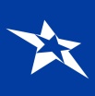 International Sculpture Symposium Alliance

Application:

1. Contact information
2. Curriculum vitae
3. Photos 3-5 of older statues in material
4. Design of the statue in sketch, or photos of the model (possible format PDF, JPG, TIFF). It´s necessary to consider durability and resistence of using elements.

If you require to get back your materials, send envelope with a postage stamp!

Application:

First name:

Surename:

Address:

Mobil phone number:

Web:

E-mail:

The name of the statue:

Idea – brief description:

The sculptor by his registering confirms that he agrees with conditions of symposium and has no other claims.

Date: Signature:

